|  |
| --- |
| **Neha Malhotra**  **R.L. Institute M: 9416974837**  **Class : XII**  **“MOLECULAR BASIS OF INHERITANCE”** |

**Level – 1**

**(Based on Structure of DNA & RNA and Search of Genetic Material)**

1. Clover leaf structure of tRNA was given by

|  |  |  |  |
| --- | --- | --- | --- |
| a) Went | b) Hemming | c) Holley | d) Meselson |

1. The following ratio is generally constant for a given species :

|  |  |  |  |
| --- | --- | --- | --- |
| a) $\frac{A+G}{C+T }$ | b) $\frac{T+C}{G+A}$ | c) $\frac{A+T}{G+C}$ | d) $\frac{A+C}{T+G}$ |

1. How many base pairs are found in the haploid genome of humans?

|  |  |  |  |
| --- | --- | --- | --- |
| a) 2.9 x 109 | b) 4 x 108 | c) 7 x 109 | d) 3.3 x 109 |

1. Eukaryotes chromosomes :
2. Are circular and contain origin and terminator sequence
3. Are linear and have origins and telomeres
4. Contain coding and non coding sequences
5. Both (b) and (c)
6. DNA is a genetic material : (i) due to its stability (ii) its ability to replicate

(iii) its ability to mutate (iv) its ability to express itself

|  |  |  |  |
| --- | --- | --- | --- |
| a) (i) , (ii) | b) (i) , (iii) , (iv) | c) (iii) , (iv) | d) all of these |

1. A sample of DNA from an unknown organism is analysed and found to contain histone proteins, more than 2 billion base pairs, and large segments of non-coding DNA. From this information, one can conclude that the organism is :

|  |  |
| --- | --- |
| a) A bacterium | b) An animal |
| c) A plant | d) Some kind of Eukaryotic organisms |

1. Which of the following parts of a DNA molecule are held together by Hydrogen bonds?
2. The carbons with in the sugar-phosphate group.
3. The carbons within the nitrogen containing bases.
4. Nucleotide bases on opposite strands of the helix
5. Successive nucleotides within a single strand of the helix
6. The primary reason, DNA was first thought to be a poor candidate for the hereditary material was that:
7. Griffth’s experiments showed that protein , not DNA cause transformation.
8. Viruses lack DNA yet still pas genetic information between generations.
9. DNA was believed to have a simple chemical structure with little variability.
10. The work of Hershey and Chase showed that protein was the genetic material

MOLECULAR BASIS OF INHERITANCE Page No. 1

1. Consider Griffth’s experiments on transformation in Streptococcus pneumoniae. Now imagine that you are extending the experiments by injecting a mixture of heat killed R-strain and live S strain bacteria into mouse. The result will be that the mouse will _______ and you will find live strain ______ bacteria in its blood.

|  |  |  |  |
| --- | --- | --- | --- |
| a) Die , R | b) Live , R | c) Die , S | d) Live , S |

1. A murder has occurred and you are asked to help and solve it. The police bring you a sample from the crime scene of what they believe is the killer’s DNA ad asked you for a chemical analysis. Your study of this sample reveals the presence of adenine , thymine , ribose and uracil, leading you to conclude that the sample is :

|  |  |
| --- | --- |
| a) pure DNA | b) Pure RNA |
| c) Probably a mixture of DNA and RNA | d) Probably a mixture of rRNA and mRNA |

1. Experiments by Avery, Macleod and McCarty supported DNA as the genetic material by showing that
2. Both protein and DNA samples provided the transforming factor.
3. DNA was not complex enough to be the genetic material
4. Only samples with DNA provided transformation activity.
5. Even though DNA was molecularity simple, it provided adequate variation to act as it genetic material.
6. Chargaff’s rules of base pairing states that :
7. The ratio of purines to pyrimidines is roughly to be the genetic material.
8. The ratio of A to T is roughly equal in all tested organisms.
9. The ratio of A + T and G + C is roughly
10. Both (a) and (b)
11. Thirty percent of the bases in a sample of DNA extracted form eukaryotic cells is adenine. What percentage of Cytosine is present in this DNA?

|  |  |  |  |
| --- | --- | --- | --- |
| a) 10 % | b) 20 % | c) 30 % | d) 40 % |

1. The two strands of DNA was held together by :

|  |  |  |  |
| --- | --- | --- | --- |
| a) peptide bons | b) phosphodiester bond | c) hydrogen bonds | d) disulphide bonds |

1. Chargaff’s rules are applicable for :

|  |  |
| --- | --- |
| a) single stranded RNA | b) single stranded DNA and RNA |
| c) single stranded DNA | d) double stranded DNA |

1. One turn of DNA possess :

|  |  |  |  |
| --- | --- | --- | --- |
| a) 1 base pair | b) 2 base pairs | c) 5 base pairs | d) 10 base pairs |

1. Which of the following is correct for Watson and Crick’s model of DNA. It is duplex with :
2. 10 base pairs and 3.4 nm distance for every turn
3. 10 base pairs and 0.34 $Å$ distance for each turn of spiral.
4. 20 base pairs and 3.4 $Å$ distance for every turn
5. None of the above
6. Histones are rich in :

|  |  |  |  |
| --- | --- | --- | --- |
| a) Alanine and glycine | b) Lysine and Arginine | c) Histidine and Serine | d) Cysteine and Tyrosine |

1. In Streptococcus pneumoniae :

|  |  |
| --- | --- |
| a) Virulent form is smooth | b) Virulent form is rough |
| c) Non-virulent form is capsulated | d) All forms are rough |

MOLECULAR BASIS OF INHERITANCE Page No. 2

1. The scientists involved in discovery of DNA as chemical basis of hereditary were:

|  |  |
| --- | --- |
| a) Hershey and Chase | b) Griffth and Avery |
| c) Avery , Macleod and McCarty | d) Watson and Crick |

1. During infection of E.coli cells by bacteriophage T2, :
2. Proteins are the only phage components that actually enter the infected cell
3. Both proteins and nucleic acid enters the cell.
4. Only protein form the infecting phage can also be detected in progeny phage.
5. Only nucleic acid enter the cell
6. If a double stranded DNA has 40 % of cytosine, what will be the percentage of adenine in it ?

|  |  |  |  |
| --- | --- | --- | --- |
| a) 20 % | b) 40 % | c) 10 % | d) 60 % |

1. A bacterium grown over medium having radioactive 35S incorporates radioactivity in :

|  |  |  |  |
| --- | --- | --- | --- |
| a) Carbohydrates | b) proteins | c) DNA | d) RNA |

1. Bacterium in which transformation was first studied is :

|  |  |
| --- | --- |
| a) Salmonella typhimurum | b) Streptococcus pneumoniae |
| c) Escherichia coli | d) Streptococcus grooves |

1. DNA has alternate grooves :

|  |  |
| --- | --- |
| a) One major and one minor | b) Two majors and one minor |
| c) One major and two minors | d) Two majors and two minors |

1. Nucleotide arrangement in DNA can be seen by :

|  |  |
| --- | --- |
| a) X-ray crystallography | b) Electron microscopy |
| c) Ultracentrifuge | d) Light microscope |

1. Circular DNA is present in :

|  |  |
| --- | --- |
| a) Endoplasmic reticulum and Ribosomes | b) Ribosomes and Chloroplasts |
| c) Ribosomes and Mitochondria | d) Mitochondria and Chloroplasts |

1. Double Hydrogen bonds occur in DNA Between :

|  |  |
| --- | --- |
| a) Adenine and thymine | b) Uracil and thymine |
| c) Adenine and guanine | d) Thymine and Cytosine |

1. Hereditary information is indicated by :

|  |  |
| --- | --- |
| a) Number of nucleic acid | b) Position of nucleic acid |
| c) sequence of nucleic acid | d) All of the above |

1. Maximum information of RNA occurs in :

|  |  |  |  |
| --- | --- | --- | --- |
| a) Cytoplasm | b) Nucleoplasm | c) Nucleolus | d) Ribosome |

1. Nucleoside is :

|  |  |
| --- | --- |
| a) Nitrogen base + Phosphate | b) Phosphate + Sugar |
| c) Nitrogen base + Sugar | d) Nitrogen Base + Sugar + Phosphate |

1. Which of the following would you not expect to find in Prokaryotic DNA?
2. Millions of base pairs
3. Histones protein around which the DNA is coiled
4. Functionally related genes group together in the same section of DNA.
5. A majority of protein that code for protein or RNA.

MOLECULAR BASIS OF INHERITANCE Page No. 3

1. Bacteriophage with radioactivity both in DNA and protein infects a bacterium. Bacterium becomes radioactive. Radioactivity occurs in :

|  |  |  |  |
| --- | --- | --- | --- |
| a) Protein | b) DNA | c) All the parts | d) Both (a) and (b) |

1. Which of the following is the most important result from the experiments of Avery and colleagues?
2. There are multiple strains of pneumonia causing bacterium
3. Only DNA is able to transform bacteria from one type to another.
4. Only proteins is able to transform bacteria from one type to another.
5. The hereditary material of Viruses is DNA.
6. If a certain molecule of DNA has a unknown amount of adenine, you automatically know that this molecule has :

|  |  |
| --- | --- |
| a) The same amount of Thymine | b) The same amount of Cytosine |
| c) The same amount of Guanine | d) No cytosine or guanosine |

1. Griffth’s experiments showing the transformation of R-strain pneumococcus bacteria to S-strain pneumococcus bacteria in the presence of heat killed S-strain bacteria gave evidence that :
2. An external factor was affecting the R-strain bacteria
3. DNA was definitely the transforming principle.
4. S-strain bacteria could be reactivated after heat killing.
5. All of the above.
6. Hershey and Chase used radioactive 35S and 32P in experiment to provide evidence that DNA was the genetic material. These experiments pointed to DNA because.
7. Progeny viruses retained 32P but not 35S.
8. Retention of 32P in progeny viruses indicated that DNA was passed on.
9. Loss of 35S in progeny viruses indicated that protein was not passed.
10. All of the above.
11. The key finding of Hershey and Chase experiments on the mechanism of viral replication was that :
12. Protein, not DNA is the hereditary material
13. DNA, not protein is the hereditary material
14. Protein and DNA play an equal role in determining inheritance
15. Neither protein or DNA paly an role in determining inheritance.
16. In tertiary structure of DNA, what is a histone octamer?
17. A complex consisting of eight positively charged histones proteins (two of each H2A , H2B , H3 and H4) that aid in the packaging of DNA.
18. A complex consisting of eight negatively charged histones proteins (two of each H2A , H2B , H3 and H4) that aid in the packaging of DNA.
19. A complex consisting of nine positively charged histones proteins (H1 and two of each H2A , H2B , H3 and H4) that aid in the packaging of DNA.
20. A complex consisting of nine negatively charged histones proteins (H1 and two of each H2A , H2B , H3 and H4) that aid in the packaging of DNA.

MOLECULAR BASIS OF INHERITANCE Page No. 4

1. In terms of DNA and RNA structure, what is a nucleotide?
2. A nucleotide is a heterocyclic base.
3. A nucleotide is a sugar molecule covalently bonded to a heterocyclic base.
4. A nucleotide is a sugar molecule bonded to phosphate and a heterocyclic base.
5. A nucleotide is a heterocyclic base bounded to phosphate group.
6. DNA exists in a double-stranded form whereas RNA is mainly a single stranded molecule. What is the likely reason for DNA being double stranded?
7. RNA strands cannot form base pairs.
8. Double stranded DNA is more stable structure.
9. DNA cannot exist in single stranded form
10. It is easier to replicate double-stranded DNA than single-stranded RNA.
11. The two strands of a double helix model of DNA are held together by hydrogen bonds between:

|  |  |
| --- | --- |
| a) Sugar and phosphate groups | b) Sugar and nitrogenous bases |
| c) Phosphate group and nitrogenous bases | d) Nitrogenous bases |

1. In DNA, base pairing occurs as :
2. Thymine with adenine and Cytosine with cytosine.
3. Adenine with thymine and Cytosine with guanine.
4. Thymine with cytosine and Guanine with adenine.
5. Adenine with cytosine and Guanine with Thymine.
6. Phosphodiester linkage is formed between :
7. C-5 of one nucleotide and C-3 of the next nucleotide.
8. C-1 of one nucleotide and C-2 of the next nucleotide.
9. Purines of opposite strands.
10. Pyrimidines of opposite strands.
11. A segment of DNA molecule contain 200 guanine and 200 thymine bases. What will be the total number of nucleotides in this segment of DNA?

|  |  |  |  |
| --- | --- | --- | --- |
| a) 400 | b) 200 | c) 800 | d) 100 |

1. According to Watson and Crick model of DNA, Deoxynucleotides are joined together by phosphodiester bond between :
2. 3’ hydroxyl of deoxyribose sugar of a nucleotide and a free 5’ phosphate group on sugar residue of other nucleotide.
3. 5’ hydroxyl of deoxyribose sugar of a nucleotide and a free 3’ phosphate group on sugar residue of other nucleotide.
4. Either (a) or (b)
5. None of the above
6. Which of the following is not relevant to the structure of double helical DNA?
7. The helix makes one complete spiral turn after every 34 $Å$.
8. The diameter of the helix is 20 $Å$.
9. The diameter between adjacent nucleotides is 3.4 $Å$.
10. Each strand of helix has a backbone made up of alternating ribose sugar and nitrogenous base.

MOLECULAR BASIS OF INHERITANCE Page No. 5

1. From the experiments carried out by Avery , mcleod and McCarty by using various enzymes, which of the following results prominently proved that DNA is the transforming material?
2. DNA of heat killed ‘S’ + R type + DNase Non-virulent strain.
3. DNA of heat killed ‘S’ + R type + RNase virulent strain.
4. DNA of heat killed ‘S’ + R type virulent strain.
5. DNA of heat killed ‘S’ + R type + protease virulent strain
6. Information flow or central dogma of modern biology is :

|  |  |
| --- | --- |
| a) RNA proteins DNA | b) Proteins DNA RNA |
| c) RNA DNA proteins | d) DNA RNA Proteins |

1. Match column I and column II

|  |  |  |  |  |
| --- | --- | --- | --- | --- |
| Column I | | Column II | | |
| A. Griffth | | I. Nucleoid | | |
| B. Hershey and Chase | | II. Active chromatin | | |
| C. Prokaryotic cell | | III. Transduction | | |
| D. Euchromatin | | IV. Transformation | | |
| a) A – I ; B – II ; C – III ; D – IV | | b) A – III ; B – I ; C – IV ; D – II |
| c) A – IV ; B – III ; C – I ; D – II | | d) A – II ; B – III ; C – I ; D – IV |

1. Which statement is/are correct?
2. DNA cannot produce its copy without DNA polymerase.
3. DNA cannot produce RNA without RNA polymerase.
4. RNA can produce complementary DNA/cDNA.
5. DNA helps in protein synthesis.

|  |  |  |  |
| --- | --- | --- | --- |
| a) (i) , (iii) , (iv) | b) (i) , (ii) , (iii) | c) (ii) , (iii) , (iv) | d) all of these |

1. Identify the incorrect statement about RNA.
2. RNA was the first genetic material to evolve in the living system.
3. Apart from being a genetic material, it is also a catalyst.
4. DNA evolved from RNA with chemical modification.
5. RNA being a catalyst is non-reactive and stable.
6. Find out the incorrect statement :
7. Uracil is present in RNA at the place of thymine.
8. The complex of DNA and protein in chromosome is called chromatin.
9. Heterochromatin is the most highly condensed form of chromatin.
10. The process involved in RNA formation on the DNA template is known as Replication.
11. Read the following statements and choose the incorrect statements :
12. Nitrogenous base is linked to the pentose sugar through a N – glycosidic linkage.
13. Phosphate group is linked to 5 – OH of a nucleoside through phosphodiester bond.
14. Two nucleotides are linked through 3’ – 5’ , N – glycosidic linkage.
15. Negatively charged DNA is wrapped around positively charged histone octamer to form nucleosomes.
16. The chromatin that is more densely packed and stains dark is called euchromatin.

|  |  |  |  |
| --- | --- | --- | --- |
| a) (i) only | b) (iv) only | c) (iii) , (v) | d) (i) , (ii) , (iii) |

MOLECULAR BASIS OF INHERITANCE Page No. 6

1. Match column I and column II

|  |  |  |  |  |
| --- | --- | --- | --- | --- |
| Column I | | Column II | | |
| A. F. Miescher | | I. DNA double helix | | |
| B. Griffth | | II. Nuclein | | |
| C. Hershey and Chase | | III. S. pneumoniae | | |
| D. Watson and Crick | | IV. Bacteriophages | | |
| E. Wilkins and Franklin | | V. X-ray diffraction studies | | |
| a) A – II ; B – III ; C – IV ; D – I ; E – V | | b) A – V ; B – IV ; C – III ; D – I ; E – II |
| c) A – I ; B – III ; C – IV ; D – II ; E – V | | d) A – I ; B – IV ; C – III ; D – II ; E – V |

1. Consider the process that a cell uses to replicate its double-stranded DNA to make copies for daughter cells. Which statement describe the DNA in daughter cells?
2. The double helix in one daughter cells consists of two strands that were originally in the parent cell, while the double helix in the other daughter cells consists of two newly made strands.
3. The two strands of the double helices in both daughter cell consists of segments of new and parental DNA.
4. The double helices in each daughter cell consists of one parental strand and one newly made strand.
5. None of the above.
6. Which of the following is an incorrect statement about DNA?
7. It is the genetic material in eukaryotes.
8. It contains all the information needed for development and existence of an organisms.
9. The quantity of DNA is different in different cells of the same organisms.
10. Every individuals has a unique DNA.
11. Which of the following statement is/are correct?
12. Nucleosome contain basic protein.
13. Tightly packed DNA of chromatin is called heterochromatin.
14. Loosely packed DNA of chromatin is called euchromatin.
15. H2A, H2B are linker proteins.
16. DNA is basic in nature.

|  |  |  |  |
| --- | --- | --- | --- |
| a) (i) , (ii) , (iii) | b) (i) , (ii) | c) (iv) , (v) | d) all of these |

1. Purines found in both DNA and RNA are :

|  |  |
| --- | --- |
| a) Adenine and Thymine | b) Adenine and Guanine |
| c) Guanine and Cytosine | d) Cytosine and thymine |

1. The association of histone H1 with a nucleosome indicates :

|  |  |
| --- | --- |
| a) DNA replication is occurring | b) The DNA is condensed into a chromatin fibre. |
| c) The DNA double helix is exposed | d) Transcription is occurring. |

1. DNA fragments are :
2. Negatively charged
3. Positively charged
4. Either positively or negatively charged depending on their size.
5. Neutral

MOLECULAR BASIS OF INHERITANCE Page No. 7

1. In sea urchin DNA, which is double stranded, 17 % of the bases were shown to be cytosine. The percentage of the three bases expected to be present in DNA are :

|  |  |  |  |
| --- | --- | --- | --- |
|  | G (%) | A (%) | T (%) |
| (a) | 17 % | 16.5 % | 32.5 % |
| (b) | 17 % | 33 % | 33 % |
| (c) | 8.5 % | 50 % | 24.5 % |
| (d) | 34 % | 24.5 % | 24.5 % |

1. Which one of the following is not applicable to RNA ?

|  |  |
| --- | --- |
| a) 5’ phosphoryl and 3’ hydroxyl ends | b) Heterocyclic nitrogenous bases |
| c) Chargaff’s rule | d) Complementary base pairing. |

1. Uridine, present only in RNA is a :

|  |  |  |  |
| --- | --- | --- | --- |
| a) Pyrimidine | b) Nucleoside | c) Nucleotide | d) Purine |

1. Which of the following does not follow the central dogma of molecular biology ?

|  |  |  |  |
| --- | --- | --- | --- |
| a) Pea | b) Mucor | c) Chlamydomonas | d) HIV |

1. The final proof for DNA as the genetic material came from the experiment of :

|  |  |
| --- | --- |
| a) Hershey and Chase | b) Avery , Mcleod and Mc Carty |
| c) Har Gobind Khorana | d) Griffth |

1. Transformation was discovered by :

|  |  |  |  |
| --- | --- | --- | --- |
| a) Meselson and Stahl | b) Hershey and Chase | c) Griffth | d) Watson and Crick |

1. The given figure shows the structure of nucleosomes with their parts labelled as A , B & C. Identify A, B, C.

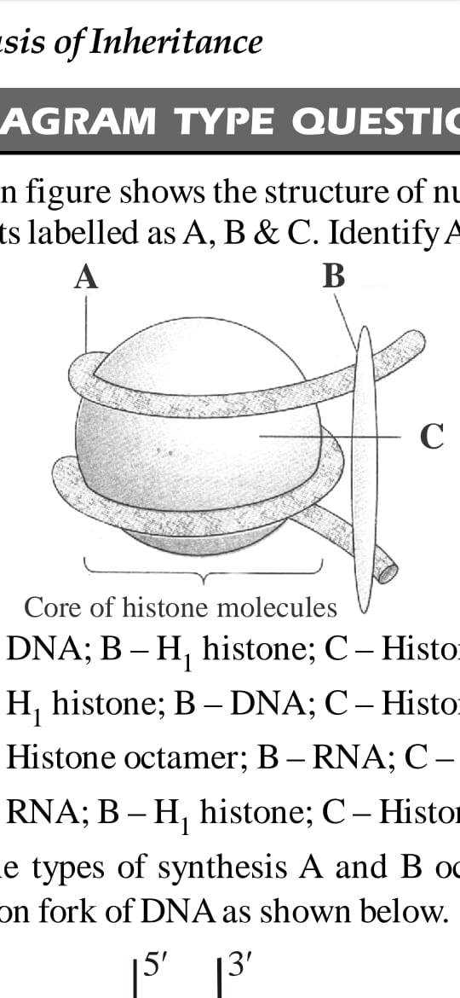

|  |  |  |  |
| --- | --- | --- | --- |
|  | A | B | C |
| (a) | DNA | H1 histone | Histone octamer |
| (b) | H1 histone | DNA | Histone octamer |
| (c) | Histone octamer | RNA | H1 histone |
| (d) | RNA | H1 histone | Histone octamer |

MOLECULAR BASIS OF INHERITANCE Page No. 8

1. Identify the correct labelling parts of A, B , C , D and E.

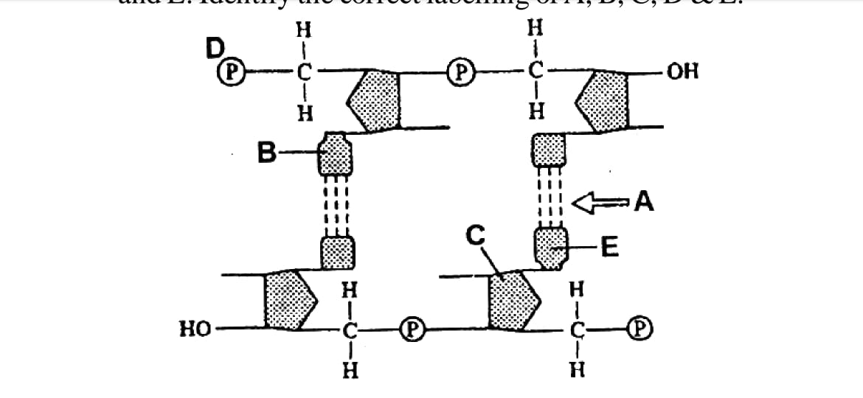

1. A – Hydrogen bond ; B – Pyrimidine ; C – Hexose (deoxyribose) sugar ; D – 5’ end ; E – Purine base
2. A – Hydrogen bond ; B – Purine ; C – Hexose (deoxyribose) sugar ; D – 5’ end ; E – Pyrimidine
3. A – Hydrogen bond ; B – Pyrimidine ; C – pentose (deoxyribose) sugar ; D – 5’ end ; E – Purine base
4. A – Hydrogen bond ; B – Purine ; C – Pentose (deoxyribose) sugar ; D – 5’ end ; E – Pyrimidine
5. Given figure represents the DNA double helix model, proposed by Watson and Crick (1953). Select the option that shows correct measurement of A , B and C marked in the figure.

|  |
| --- |
|  |

|  |  |  |  |
| --- | --- | --- | --- |
|  | A | B | C |
| (a) | 3.4 nm | 0.34 nm | 2 nm |
| (b) | 34 nm | 3.4 nm | 20 nm |
| (c) | 3.4 $Å$ | 0.34 $Å$ | 20 $Å$ |
| (d) | 34 $Å$ | 3.4 $Å$ | 2 $Å$ |

MOLECULAR BASIS OF INHERITANCE Page No. 9

**Answers**

|  |  |  |  |  |  |  |  |
| --- | --- | --- | --- | --- | --- | --- | --- |
| 1. c | 1. a | 1. d | 1. d | 1. d | 1. d | 1. c | 1. c |
| 1. c | 1. c | 1. c | 1. d | 1. b | 1. c | 1. d | 1. d |
| 1. a | 1. b | 1. a | 1. c | 1. d | 1. c | 1. b | 1. b |
| 1. a | 1. a | 1. d | 1. a | 1. c | 1. c | 1. c | 1. b |
| 1. b | 1. b | 1. a | 1. a | 1. d | 1. b | 1. a | 1. c |
| 1. b | 1. d | 1. b | 1. a | 1. c | 1. a | 1. d | 1. a |
| 1. d | 1. c | 1. b | 1. d | 1. d | 1. c | 1. a | 1. c |
| 1. c | 1. a | 1. b | 1. b | 1. a | 1. b | 1. c | 1. b |
| 1. d | 1. a | 1. c | 1. a | 1. d | 1. a |  |  |

MOLECULAR BASIS OF INHERITANCE Page No. 10

|  |
| --- |
| **Neha Malhotra**  **R.L. Institute M: 9416974837**  **Class : XII**  **“MOLECULAR BASIS OF INHERITANCE”** |

**Level – 2**

**(Based on Replication and Transcription)**

1. The area of unwinding and separation of DNA strands during replication is called as:

|  |  |  |  |
| --- | --- | --- | --- |
| a) Origin | b) Initial point | c) Primer | d) Replication fork |

1. Okazaki fragments are joined by :

|  |  |  |  |
| --- | --- | --- | --- |
| a) DNA polymerase III | b) DNA ligase | c) DNA polymerase II | d) DNA polymerase I |

1. Okazaki fragments give rise to :

|  |  |  |  |
| --- | --- | --- | --- |
| a) Master strand | b) Sense strand | c) Lagging strand | d) Leading strand |

1. Leading strand during DNA replication is formed :

|  |  |  |  |
| --- | --- | --- | --- |
| a) Continuously | b) In short segments | c) First | d) Ahead of replication |

1. Genetic information (DNA) is carried out by long chain molecule made up of :

|  |  |  |  |
| --- | --- | --- | --- |
| a) Amino acids | b) enzymes | c) Nucleotides | d) Histone proteins |

1. Ligase is an enzyme required for :

|  |  |
| --- | --- |
| a) Breaking of DNA | b) Joining DNA bits |
| c) Renaturation of DNA | d) Proofreading |

1. In some virus, RNA is present instead of DNA indicating that :
2. Their nucleic acid must combine with host DNA before replication.
3. They cannot replicate
4. There is no hereditary information.
5. RNA can act to transfer heredity.
6. Enzyme required for removing RNA primer during DNA replication is :

|  |  |  |  |
| --- | --- | --- | --- |
| a) Primase | b) Ligase | c) DNA polymerase I | d) DNA polymerase III |

1. DNA polymerase III is composed of how many polypeptides?

|  |  |  |  |
| --- | --- | --- | --- |
| a) 5 | b) 6 | c) 4 | d) 7 |

1. RNA polymerase III transcribes.

|  |  |  |  |
| --- | --- | --- | --- |
| a) tRNA | b) ssDNA | c) mRNA | d) Reverse transcriptase |

1. DNA replication is

|  |  |
| --- | --- |
| a) Conservation and discontinuous | b) Semi-conservative and semi-discontinuous |
| c) Semi-conservative and discontinuous | d) Conservative |

1. Segment of mRNA removed during splicing are called ___________.

|  |  |  |  |
| --- | --- | --- | --- |
| a) introns | b) exons | c) Promoter regions | d) Integrator regions |

MOLECULAR BASIS OF INHERITANCE Page No. 11

1. The formation of DNA from RNA is known as :

|  |  |  |  |
| --- | --- | --- | --- |
| a) Translation | b) Transcription | c) Replication | d) Reverse transcription |

1. When a molecule of DNA replicates without error, each of the resulting molecules contains :

|  |  |
| --- | --- |
| a) The same amount of A as T | b) The same amount of G as C |
| c) One new strand and one old strand | d) All of the above |

1. Which of the following characters is not associated with a leading strand?
2. Its replication proceeds away from the fork.
3. Its replication takes place in continuous manner.
4. Its replication takes place on template strand with 3’ – 5’ polarity
5. All of the above.
6. A scientist isolated mRNA whose bases are 2000 less than the corresponding DNA sequence. What can you infer from this?

|  |  |
| --- | --- |
| a) Scientist isolated wrong mRNA | b) Scientist isolated wrong DNA |
| c) Scientist isolated alien species DNA | d) mRNA contains exon only |

1. DNA replication is semi-conservative as :
2. Only parental strand act as template.
3. Both strand of new molecule are synthesized .
4. One of the strand in each molecule is parental and the other is new.
5. Daughter strand is dispersive.
6. DNA polymerization rate of DNA polymerase is :

|  |  |  |  |
| --- | --- | --- | --- |
| a) 3.9 x 107 bp | b) 2000 bp/s | c) 4.6 x 106 bp | d) 5000 bp/s |

1. In Meselson and Stahl’s experiments, heavy DNA was distinguished from normal DNA by centrifugation in

|  |  |  |  |
| --- | --- | --- | --- |
| a) CsOH gradient | b) 14NH4Cl | c) 15NH4Cl | d) CsCl gradient |

1. The primary function of DNA polymerase is to :
2. Add nucleotides to the growing daughter strand.
3. Seal nicks along the sugar-phosphate backbone of the daughter strand.
4. Unwind the parent DNA double helix.
5. Prevent reassociation of the denaturated parent DNA strands.
6. RNA primers are necessary in DNA synthesis because :
7. DNA polymerase can only add to an existing strand of nucleotides.
8. DNA polymerase can only add to an existing DNA strand.
9. DNA primase is the first enzyme in the replication complex.
10. All of the above.

MOLECULAR BASIS OF INHERITANCE Page No. 12

1. Match column I and column II

|  |  |  |  |  |
| --- | --- | --- | --- | --- |
| Column I | | Column II | | |
| A. Helicase | | I. Joining of nucleotide | | |
| B. Gyrase | | II. Opening of DNA | | |
| C. Primase | | III. Unwinding of DNA | | |
| D. DNA polymerase III | | IV. RNA priming | | |
| a) A – II ; B – I ; C – III ; D – IV | | b) A – II ; B – I ; C – IV ; D – III |
| c) A – IV ; B – III ; C – I ; D – II | | d) A – II ; B – III ; C – IV ; D – Is |

1. Match column I and column II

|  |  |  |  |  |
| --- | --- | --- | --- | --- |
| Column I | | Column II | | |
| A. Splicing | | I. Lac operon | | |
| B. Okazaki fragment | | II. Lagging strands | | |
| C. Jacob and Monad | | III. Lactose | | |
| D. Inducer | | IV. Removal of introns | | |
| a) A – IV ; B – II ; C – I ; D – III | | b) A – II ; B – I ; C – IV ; D – III |
| c) A – IV ; B – III ; C – I ; D – II | | d) A – II ; B – III ; C – I ; D – IV |

1. Which of the following statements about DNA replication is incorrect?
2. Okazaki fragments are the initiators of continuous DNA synthesis along the leading strand.
3. Replication forks represent areas of active DNA synthesis on the chromosomes.
4. Error rates for DNA replication are often less than one in every billion base pairings.
5. Ligases and polymerases function in the vicinity of replication of replication forks.
6. Which of the following statement is correct about DNA polymerase?
7. DNA polymerase can synthesis mRNA in the 3’ to 5’ direction.
8. DNA polymerase can synthesis DNA in the 5’ to 3’ direction.
9. DNA polymerase can synthesis mRNA in the 5’ to 3’ direction.
10. DNA polymerase can synthesis DNA in the 3’ to 5’ direction.
11. The experimental proof for semi-conservative replication of DNA was first shown in a :

|  |  |  |  |
| --- | --- | --- | --- |
| a) Fungus | b) Bacterium | c) Virus | d) Plant |

1. During DNA replication, Okazaki fragments are used to elongate :
2. The lagging strand towards replication fork
3. The leading strand away from replication fork.
4. The lagging strand away from replication fork.
5. The leading strand towards replication fork.
6. The process of gene transcription begins with the :
7. Binding of RNA polymerase to a region of DNA called the promoter.
8. Removal of introns form the newly formed mRNA.
9. Joining of rRNA with various ribosomal proteins.
10. Attachment of an mRNA molecule to the ribosome.

MOLECULAR BASIS OF INHERITANCE Page No. 13

1. Spliceosomes are not found in cells of :

|  |  |  |  |
| --- | --- | --- | --- |
| a) Fungi | b) Animals | c) Bacteria | d) Plants |

1. Methyl Guanosine triphosphate is added at 5’ end of hnRNA in a process of :

|  |  |  |  |
| --- | --- | --- | --- |
| a) Tailing | b) splicing | c) Capping | d) None of these |

1. In Eukaryotes, mRNA is synthesized with the aid of :

|  |  |  |  |
| --- | --- | --- | --- |
| a) RNA polymerase III | b) RNA polymerase II | c) RNA polymerase I | d) Reverse transcriptase |

1. If you expose a cell to chemicals that specifically disrupt the function of RNA polymerase, which of the following processes will be most directly impacted?

|  |  |  |  |
| --- | --- | --- | --- |
| a) Transcription | b) Translation | c) DNA replication | d) Rate of mutation |

1. Transcription in prokaryotic cell is :
2. Initiation at a promoter using one of three RNA polymerase (RNA polymerase II).
3. Initiated at a start codon with the help of initiation factors and the small subunit of the ribosome.
4. Initiated at a promoter and uses only one strand of DNA, the template strand, to synthesis a complementary RNA strand.
5. Terminated at stop codons.
6. During elongation step of transcription, sigma factor is :

|  |  |
| --- | --- |
| a) Functionless | b) Retained for specific function |
| c) Released for reuse | d) Required during closing of chain. |

1. Transcription :
2. Starts at initiator region and ends at stop region
3. Starts at operator region and ends at telomere end
4. Starts at promoter region and ends at terminator region.
5. Start at CAAT box and ends at TATA box.
6. What can be observed if both the strands are copied simultaneously during transcription?
7. The segments of DNA would be coding for two different proteins.
8. Two RNA will be produced simultaneously complementary to each other.
9. Formation of double helical RNA.
10. All of these
11. A short sequence of bases on one strand of DNA is AGTCTACCGATAGT. If this sequence server as a template for the formation of a new strand of DNA, what will be the corresponding base sequence in the new strand?

|  |  |  |  |
| --- | --- | --- | --- |
| a) AGTCTACCGATAGT | b) TCAGATGGCTATCA | c) TGATAGCCATCTGA | d) GACATCGATTCGAT |

1. What is the main function of tRNA in relation to protein synthesis?
2. Initiates transcription.
3. Inhibits protein synthesis.
4. Identifies amino acids and transports them to ribosomes.
5. Proofreading

MOLECULAR BASIS OF INHERITANCE Page No. 14

1. Introns are DNA sequence that :
2. Code for functional domains in proteins.
3. Are removed from pre-mRNA by spliceosomes.
4. Allow one gene to make different gene products depending on which introns are removed during splicing.
5. Both (b) and (c)
6. Select the correct statement regarding protein synthesis.
7. When the small subunit of the ribosome encounters an mRNA the process of translation begins.
8. Peptidase catalyses the formation of peptide bond.
9. UTRs are present between the start codon and stop codon.
10. At the end of translation, the release factor binds to the initiation codon.
11. A DNA strand with the sequence AACGTAACG is transcribed. What is the sequence of the mRNA molecule synthesis?

|  |  |  |  |
| --- | --- | --- | --- |
| a) AACGTAACG | b) UUGCAUUGC | c) AACGUAACG | d) TTGCATTGC |

1. Match column I and column II

|  |  |  |  |  |
| --- | --- | --- | --- | --- |
| Column I | | Column II | | |
| A. Sigma factor | | I. 5’ – 3’ | | |
| B. Capping | | II. Initiation | | |
| C. Tailing | | III. Termination | | |
| D. Coding strand | | IV. 5’ end | | |
|  | | V. 3’ end | | |
| a) A – III ; B – V ; C – IV ; D – II | | b) A – II ; B – IV ; C – V ; D – I |
| c) A – II ; B – IV ; C – V ; D – III | | d) A – III ; B – V ; C – IV ; D – I |

1. Match column I and column II

|  |  |  |  |  |
| --- | --- | --- | --- | --- |
| Column I | | Column II | | |
| A. Exon | | I. coding sequence | | |
| B. Intron | | II. Cistron | | |
| C. Genetic code | | III. Triplet bases on mRNA | | |
| D. DNA packaging | | IV. Nucleosome | | |
|  | | V. Non-coding sequence | | |
| a) A – I ; B – III ; C – II ; D – V | | b) A – I ; B – IV ; C – II ; D – III |
| c) A – I ; B – V ; C – III ; D – IV | | d) A – IV ; B – I ; C – V ; D – III |

1. Identify the incorrect statements.
2. In eukaryotes, there are at least three RNA polymerase.
3. hnRNA is formed in both Prokaryotes and Eukaryotes.
4. hnRNA has both exons and introns.
5. Any mistakes in DNA replication may cause infection.

MOLECULAR BASIS OF INHERITANCE Page No. 15

1. Choose the sequence in which the following enzymes take part in DNA replication.

(i) Helicase (ii) Primase (iii) SSBP (iv) DNA polymerase (v) DNA ligase

|  |  |
| --- | --- |
| a) (i) $→$ (v) $→$ (iv) $→$ (iii) $→$ (ii) | b) (i) $→$ (ii) $→$ (iii) $→$ (iv) $→$ (v) |
| c) (i) $→$ (iii) $→$ (ii) $→$ (iv) $→$ (v) | d) (i) $→$ (iv) $→$ (iii) $→$ (ii) $→$ (v) |

1. Spliceosomes are not found in cells of :

|  |  |  |  |
| --- | --- | --- | --- |
| a) Fungi | b) Animals | c) Bacteria | d) Plants |

1. Select the correct option :

|  |  |  |
| --- | --- | --- |
|  | Direction of RNA synthesis | Direction of reading of the template DNA strand |
| (a) | 5’ – 3’ | 3’ – 5’ |
| (b) | 3’ – 5’ | 5’ – 3’ |
| (c) | 5’ – 3’ | 5’ – 3’ |
| (d) | 3’ – 5’ | 3’ – 5’ |

1. Removal of introns and joining of exons in a defined order during transcription is called:

|  |  |  |  |
| --- | --- | --- | --- |
| a) looping | b) inducing | c) Slicing | d) Splicing |

1. Which one of the following is not a part of a transcription unit in DNA?

|  |  |  |  |
| --- | --- | --- | --- |
| a) The inducer | b) A terminator | c) A promoter | d) The structural gene |

1. Removal of RNA polymerase III from nucleoplasm will affect the synthesis of :

|  |  |  |  |
| --- | --- | --- | --- |
| a) tRNA | b) hnRNA | c) mRNA | d) rRNA |

1. If one strand of DNA has the nitrogenous base sequence at ATCTG, what would be the complementary RNA strand sequence :

|  |  |  |  |
| --- | --- | --- | --- |
| a) TTAGU | b) UAGAC | c) AACTG | d) ATCGU |

1. Which of the following statement is wrong about transcription in bacteria?
2. Splicing is not required.
3. Multiple RNA polymerase transcribes all DNA polymerases.
4. This process requires more/less energy.
5. None of these.
6. The given figure represents one of the steps in the process of transcription in bacteria. Identify the step and labels A , B and C marked in the figure.

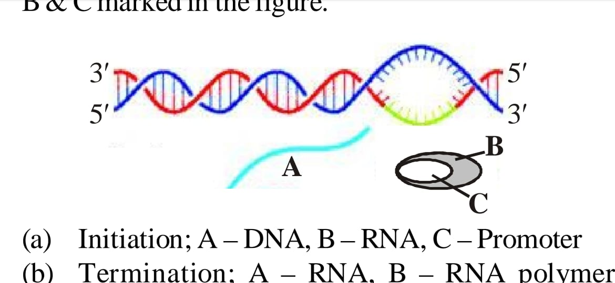

1. Initiation ; A – DNA , B – RNA , C – Promoter.
2. Termination ; A – RNA , B – RNA polymerase , C – Rho factor.
3. Elongation ; A – RNA , B – RNA polymerase , C – Sigma factor.
4. Elongation ; A – DNA , B – DNA polymerase , C – RNA.

MOLECULAR BASIS OF INHERITANCE Page No. 16

1. Name the type of synthesis A and B occurring in the replication fork of DNA as shown below.

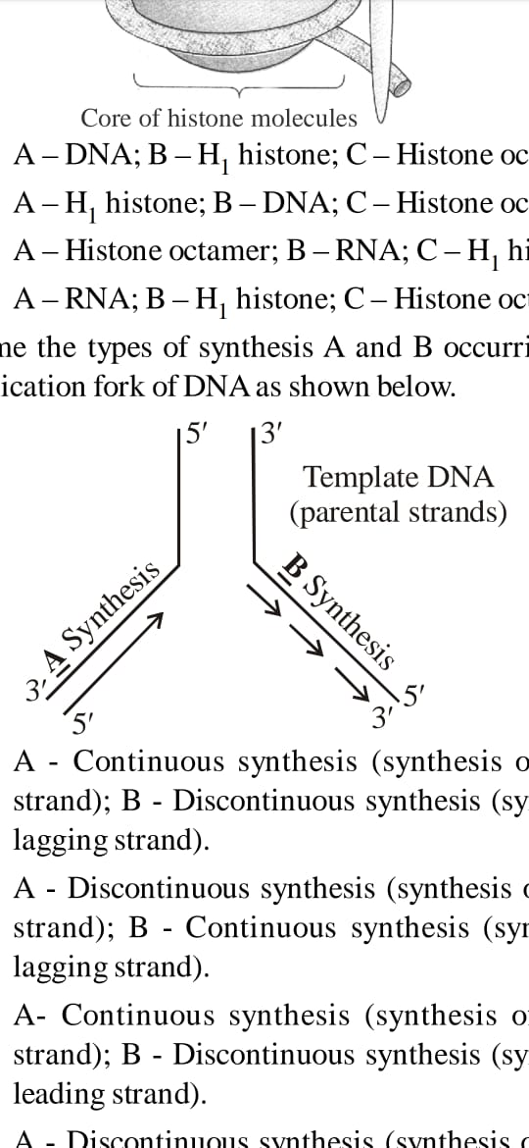

1. A – Continuous synthesis (synthesis of leading strand) ; B – Discontinuous synthesis (synthesis of lagging strand).
2. A – Discontinuous synthesis (synthesis of leading strand) ; B – Continuous synthesis (synthesis of lagging strand).
3. A – Continuous synthesis (synthesis of lagging strand) ; B – Discontinuous synthesis (synthesis of leading strand).
4. A – Discontinuous synthesis (synthesis of lagging strand) ; B – Continuous synthesis (synthesis of leading strand).
5. Given diagram represents the schematic structure of a transcription unit with some parts labelled as A , B , C and D. Select the option which shows their correct labelling.

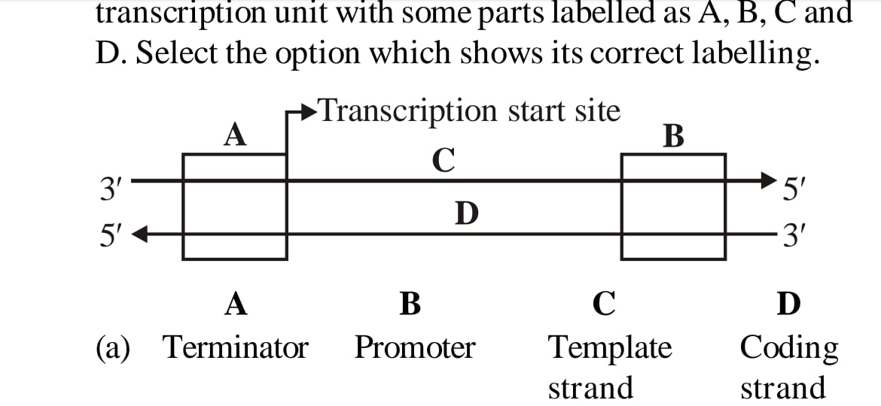

|  |  |  |  |  |
| --- | --- | --- | --- | --- |
|  | A | B | C | D |
| (a) | Terminator | Promoter | Template strand | Coding strand |
| (b) | Promoter | Terminator | Coding strand | Template strand |
| (c) | Promoter | Terminator | Template strand | Coding strand |
| (d) | Terminator | Promoter | Coding strand | Template strand |

MOLECULAR BASIS OF INHERITANCE Page No. 17

**Answers**

|  |  |  |  |  |  |  |  |
| --- | --- | --- | --- | --- | --- | --- | --- |
| 1. a | 1. b | 1. c | 1. a | 1. c | 1. b | 1. d | 1. c |
| 1. d | 1. a | 1. b | 1. a | 1. d | 1. d | 1. a | 1. d |
| 1. c | 1. b | 1. d | 1. a | 1. a | 1. d | 1. a | 1. a |
| 1. b | 1. b | 1. c | 1. a | 1. c | 1. c | 1. b | 1. a |
| 1. c | 1. a | 1. c | 1. d | 1. b | 1. c | 1. b | 1. a |
| 1. b | 1. c | 1. b | 1. c | 1. c | 1. a | 1. d | 1. d |
| 1. a | 1. a | 1. b | 1. b | 1. b | 1. a | 1. c |  |

MOLECULAR BASIS OF INHERITANCE Page No. 18

|  |
| --- |
| **Neha Malhotra**  **R.L. Institute M: 9416974837**  **Class: XII**  **“MOLECULAR BASIS OF INHERITANCE”** |

**Level – 3**

**(Based on RNA World , Genetic Code and Translation)**

1. A small segment of DNA contains the base sequence CGT. If an mRNA transcript is made that includes this DNA sequence, what will be the anticodon on the tRNA that will bind to the corresponding mRNA codon for this DNA triplet?

|  |  |  |  |
| --- | --- | --- | --- |
| a) CGT | b) GCA | c) CGU | d) GCT |

1. A functional piece of mRNA has 66 codons. What is the maximum number of amino acids that could be present in the protein, coded for this mRNA?

|  |  |  |  |
| --- | --- | --- | --- |
| a) 22 | b) 64 | c) 65 | d) 66 |

1. A triplet base sequence in DNA reads ATT. What will be the corresponding mRNA codon, tRNA anticodon, and amino of acid called by this DNA?

|  |  |
| --- | --- |
| a) TAA; UTT; methionine | b) TAA; AUU; no amino acid (= stop codon) |
| c) UAA; no tRNA exist; no amino acid (= stop codon) | d) CGG;GCC; alanine |

1. In order for the information contained in a gene to be used to produce a functioning protein, the:
2. DNA must be replicated
3. information must be transcribed into mRNA and then translated into amino acids.
4. tRNA must be transcribed into rRNA and then translated into amino acids.
5. ribosome must be converted from rRNA into mRNA
6. Which one of the following triplet code, is correctly matched with its specificity for an amino acid in protein synthesis or as ‘start’ or ‘stop’ codon?

|  |  |  |  |
| --- | --- | --- | --- |
| a) UAC-Tyrosine | b) UCG-Start | c) UUU-Stop | d) UGU-Leucine |

1. What would happen if in a gene encoding a polypeptide of 50 amino acids, 25th codon (UAU) is mutated to UAA?
2. A polypeptide of 25 amino acids will be formed.
3. A polypeptide of 24 amino acids will be formed.
4. Two polypeptides of 24 and 25 amino acids will be formed.
5. A polypeptide of 49 amino acids will be formed.
6. In the genetic code dictionary, how many codons are used to code for all the 20 essential amino acids?

|  |  |  |  |
| --- | --- | --- | --- |
| a) 61 | b) 64 | c) 60 | d) 20 |

1. Methionine carrying tRNA, has an anticodon:

|  |  |  |  |
| --- | --- | --- | --- |
| a) AUG | b) UAG | c) UAC | d) UAA |

MOLECULAR BASIS OF INHERITANCE Page No. 19

1. AUG initiation codon occurs over:

|  |  |  |  |
| --- | --- | --- | --- |
| a) 3' end of mRNA | b) 5' end of mRNA | c) Short arm of tRNA | d) Long arm of tRNA |

1. Polypeptide chain in eukaryotes is initiated by:

|  |  |  |  |
| --- | --- | --- | --- |
| a) Glycine | b) Leucine | c) Methionine | d) Lysine |

1. Non-sense codon takes part in
2. terminating message of gene controlled protein synthesis
3. formation of unspecified amino acids
4. conversion of sense DNA into non-sense one.
5. releasing tRNA from polypeptide chain.
6. Termination of polypeptide chain is brought about by:

|  |  |
| --- | --- |
| a) UUG, UAG and UCG | b) UAA, UAG and UGA |
| c) UUG, UGC and UCA | d) UCG, GCG and ACC |

1. Codon AUG specifies:

|  |  |  |  |
| --- | --- | --- | --- |
| a) Methionine | b) Valine | c) Tyrosine | d) Phenylalanine |

1. Triplet UUU codes for-

|  |  |  |  |
| --- | --- | --- | --- |
| a) Leucine | b) Methionine | c) Phenylalanine | d) Glycine |

1. Genetic code is
2. triplet, universal, ambiguous and degenerate.
3. triplet, universal, non-ambiguous and non-degenerate
4. triplet, universal, non-ambiguous and degenerate
5. triplet, universal, ambiguous and non-degenerate
6. Who gave the First experimental proof of triplet code?

|  |  |  |  |
| --- | --- | --- | --- |
| a) George Gamow | b) Nirenberg | c) Kornberg | d) Khorana |

1. Which one of the following group of codons is called as non-sense codons?

|  |  |
| --- | --- |
| a) UAA, UAG and UGA | b) GUA, GUG, GCA, GCG and GAA |
| c) UUC, UUG CCU, CAA and CUG | d) UUA, UUG CUU, CUC, CUA and CUG |

1. Which of the following is not a property of the genetic code?

|  |  |  |  |
| --- | --- | --- | --- |
| a) Universal | b) Non-overlapping | c) Ambiguous | d) Degeneracy |

1. Which one of the following is the starter codon?

|  |  |  |  |
| --- | --- | --- | --- |
| a) AUG | b) UGA | c) UAA | d) UAG |

1. Select the incorrect statement(s)
2. 6 codons do not code for any amino acid.
3. Codon is read in mRNA in a contiguous fashion.
4. Three codons function as stop codons.
5. The initiation codon AUG codes for methionine

|  |  |  |  |
| --- | --- | --- | --- |
| a) (i) only | b) (ii) only | c) (i), (ii) and (iv) | d) (i), (ii)and(iii) |

MOLECULAR BASIS OF INHERITANCE Page No. 20

1. A geneticist isolates a gene for a specific trait understudy. She also isolates the corresponding mRNA. Upon comparison, mRNA is found to contain 1,000 fewer(lesser) bases than the DNA sequence. Did the geneticist isolate the wrong DNA?
2. Yes, mRNA is made from a DNA template and should be of same length as the gene sequence
3. Yes, mRNA should contain more bases than the DNA sequence because bases flanking the gene are also transcribed.
4. No, the final mRNA contains only exons, the introns were removed
5. No, mRNA was partially degraded after it was transcribed.
6. Which of the following factors are required for the protein synthesis?
7. Initiation codon
8. GTP and ATP
9. Peptidyl transferase
10. tRNA
11. mRNA
12. Amino acid activating enzyme
13. rRNA

Choose the correct combination.

|  |  |  |  |
| --- | --- | --- | --- |
| a) (i), (ii) and (iii) | b) (iii), (iv) and (v) | c) (v), (vi) and (vii) | d) All of these |

1. Protein synthesis occurs:
2. on ribosomes present in cytosol as well as in mitochondria
3. only on ribosomes present on Golgi body.
4. only on the ribosomes present in cytosol
5. on ribosomes present in the nucleolus as well as cytoplasm.
6. Which step of translation does not consume a high energy phosphate bond?

|  |  |
| --- | --- |
| a) Translocation | b) Amino acid activation |
| c) Peptidyl transferase reaction | d) Aminoacyl tRNA binding to active ribosomal site |

1. Code transfer for synthesis of polypeptide involves:

|  |  |
| --- | --- |
| a) DNA, tRNA, rRNA and mRNA | b) mRNA, tRNA, rRNA and DNA |
| c) RNA, DNA, mRNA and rRNA | d) DNA, mRNA, tRNA and amino acids |

1. In polypeptide synthesis, amino acids are brought over ribosome-mRNA complex by:

|  |  |  |  |
| --- | --- | --- | --- |
| a) rRNA | b) tRNA | c) DNA | d) Nucleotides |

1. tRNA attaches to amino acid at its:

|  |  |  |  |
| --- | --- | --- | --- |
| a) 3' end | b) 5' end | c) Anticodon | d) Loop |

1. Translation of messenger RNA into protein
2. in a 3' to 5' direction and from N terminus to C terminus.
3. in a 5' to 3' direction and from N terminus to C terminus.
4. in a 3' to 5' direction and from C terminus to N terminus.
5. in a 5' to 3' direction and from C terminus to N terminus

MOLECULAR BASIS OF INHERITANCE Page No. 21

1. What would happen if a mutation occurred in the DNA such that the second codon of polypeptide, UGC, was changed to a UAG?
2. Nothing. The ribosome would skip that codon and translation would continue.
3. Translation would continue, but the reading frame of the ribosome would be shifted.
4. Translation would stop at the second codon and no functional protein would be made
5. Translation would continue, but the second amino acid in the protein would be different.
6. During translation, proteins are synthesized by:

|  |  |
| --- | --- |
| a) ribosomes using the information on DNA | b) lysosome using the information on DNA |
| c) ribosome using the information on mRNA | d) lysosome using the information on mRNA |

1. Number of amino acids in a polypeptide chain is 150. The number of mRNA bases required is:

|  |  |  |  |
| --- | --- | --- | --- |
| a) 150 | b) 450 | c) 100 | d) 50 |

1. Transcription contains 30 nucleotides. Then the maximum number of amino acids contained in the corresponding protein will be:

|  |  |  |  |
| --- | --- | --- | --- |
| a) 20 | b) 10 | c) 30 | d) 25 |

1. Given below are the steps of protein synthesis. Arrange them in correct sequence and select the correct option.
2. Codon-anticodon reaction between mRNA and aminoacyl tRNA complex.
3. Attachment of mRNA and smaller sub-unit of ribosome.
4. Charging or aminoacylation of tRNA.
5. Attachment of larger sub-unit of ribosome to the mRNA-tRNAMET complex.
6. Linking of adjacent amino acids.
7. Formation of polypeptide chain.

|  |  |
| --- | --- |
| a) (ii) –> (i) –> (iii) –> (v) –> (iv) –> (vi) | b) (v) –> (ii) –> (i) –> (iii) –> (iv) –> (vi) |
| c) (iii) –> (ii) –> (iv) –> (i) –> (v) –> (vi) | d) (iii) –> (ii) –> (i) –> (iv) –> (v) –> (vi) |

1. Which of the following statements about RNA polymerase are correct ?
2. RNA polymerase I transcribes rRNAs.
3. RNA polymerase II transcribes snRNAs.
4. RNA polymerase III transcribes hnRNA.
5. RNA polymerase II transcribes hnRNA.

|  |  |  |  |
| --- | --- | --- | --- |
| a) (i) and (ii) | b) (i) and (iii) | c) (ii) and (iii) | d) (i) and (iv) |

1. Match the column-I and column-II and find the correct option

|  |  |
| --- | --- |
| **Column – I** | **Column – II** |
| 1. RNA polymerase I | 1. Formation of tRNA |
| 1. RNA polymerase II | 1. Formation of rRNA |
| 1. RNA polymerase III | 1. Formation of hnRNA |

|  |  |
| --- | --- |
| a) A – II; B – III; C – I | b) A – I; B – II; C – III |
| c) A – III; B – I; C – II | d) A – II; B – I; C – III |

MOLECULAR BASIS OF INHERITANCE Page No. 22

1. Identify the correct statement
2. In prokaryotes, single RNA polymerase transcribes mRNA, tRNA and rRNA
3. RNA polymerase I transcribes 28S, 18S, 5.8S rRNA
4. RNA polymerase Ill transcribes 5S rRNA and tRNA
5. RNA polymerase II transcribes hnRNA
6. Ribosomal large subunit has P , A and E site.

|  |  |  |  |
| --- | --- | --- | --- |
| a) (i), (ii), (iii), (iv) and (v) | b) (i), (ii), (iii) | c) (iii), (iv) and (v) | d) (i), (iv) and (iii) |

1. Which of the following statements are correct?
2. rRNA provides the template for synthesis of proteins
3. tRNA brings amino acids and reads the genetic code
4. RNA polymerase binds to promoter and initiates transcription.
5. A segment of DNA coding for polypeptide is called intron

|  |  |  |  |
| --- | --- | --- | --- |
| a) (i) and (ii) | b) (i) and (iii) | c) (i), (ii) and (iii) | d) (ii) and (iii) |

1. Match column-I with column-II and select the correct answer using the codes given below.

|  |  |
| --- | --- |
| **Column – I** | **Column – II** |
| 1. Termination | 1. Aminoacyl tRNA synthetase |
| 1. Translation | 1. Okazaki Fragments |
| 1. Transcription | 1. GTP dependent release factor |
| 1. DNA replication | 1. RNA polymerase |

|  |  |
| --- | --- |
| a) A – II; B – I; C – III; D – IV | b) A – III; B – I; C – IV; D – II |
| c) A – IV; B – III; C – I; D – II | d) A – II; B – III; C – I; D – IV |

1. tRNA recognizes ribosome by:

|  |  |  |  |
| --- | --- | --- | --- |
| a) Tψ C loop | b) DHU loop | c) Anticodon | d) AA site |

1. Select the wrong pair.

|  |  |
| --- | --- |
| a) RNA polymerase I – snRNA, 5S rRNA, rRNA | b) RNA polymerase I – rRNA |
| c) RNA polymerase II – hnRNA | d) RNA polymerase I – tRNA |

1. Termination of protein synthesis needs
2. AUG codon and sigma factor
3. GUG and Rho factor
4. Stop signal/Non-sense codon
5. Release/termination factor

Which of the following are correct?

|  |  |  |  |
| --- | --- | --- | --- |
| a) (i), (iii) | b) (i), (ii), (iii), (iv) | c) (iii), (iv) | d) (i), (ii), (iii) |

1. Many ribosomes may associate with single mRNA to form multiple copies of a polypeptide simultaneously. Such strings of ribosomes are termed as:

|  |  |  |  |
| --- | --- | --- | --- |
| a) Polysome | b) Polyhedral bodies | c) Nucleosome | d) Plastidome |

MOLECULAR BASIS OF INHERITANCE Page No. 23

1. A complex of ribosomes attached to a single strand of RNA is known as:

|  |  |  |  |
| --- | --- | --- | --- |
| a) Polysome | b) Polymer | c) Polypeptide | d) Okazaki fragment |

1. Identify the labels A, B, C and D in the given structure of tRNA and select the correct option

|  |  |  |  |  |
| --- | --- | --- | --- | --- |
|  | **A** | **B** | **C** | **D** |
|  | Anticodon loop | Tψ C loop | AA binding site | DHU loop |
|  | AA binding site | Tψ C loop | Anticodon loop | DHU loop |
|  | AA binding site | DHU loop | Anticodon loop | Tψ C loop |
|  | AA binding site | DHU loop | Tψ C loop | Anticodon loop |

MOLECULAR BASIS OF INHERITANCE Page No. 24

**Answers**

|  |  |  |  |  |  |  |  |
| --- | --- | --- | --- | --- | --- | --- | --- |
| 1. c | 1. c | 1. c | 1. b | 1. a | 1. b | 1. a | 1. c |
| 1. b | 1. c | 1. a | 1. b | 1. a | 1. c | 1. c | 1. b |
| 1. a | 1. c | 1. a | 1. a | 1. c | 1. d | 1. a | 1. d |
| 1. d | 1. b | 1. a | 1. b | 1. c | 1. c | 1. b | 1. b |
| 1. d | 1. d | 1. a | 1. a | 1. d | 1. b | 1. a | 1. a |
| 1. c | 1. a | 1. a | 1. b |  |  |  |  |
|  |  |  |  |  |  |  |  |

MOLECULAR BASIS OF INHERITANCE Page No. 25

**Level-4**

**(Based on Operon System, HGP and DNA Fingerprinting)**

|  |
| --- |
| **Neha Malhotra**  **R.L. Institute M: 9416974837**  **Class: XII**  **“MOLECULAR BASIS OF INHERITANCE”** |

1. Operon is a
2. Sequence of three nitrogen bases determining a single amino acid
3. Set of closely placed genes regulating a metabolic pathway in prokaryotes
4. Segment of DNA specifying a polypeptide
5. Gene responsible for switching on and off other genes
6. Regulated unit of genetic material is termed as:

|  |  |  |  |
| --- | --- | --- | --- |
| a) Operon | b) Regulator gene | c) Operator gene | d) Okazaki fragment |

1. In a prokaryote, a repressor protein may block gene expression by binding to a DNA site called:

|  |  |  |  |
| --- | --- | --- | --- |
| a) Operon | b) Structural gene | c) Operator | d) Promoter |

1. What does "lac" refer to in what we call the lac operon?

|  |  |  |  |
| --- | --- | --- | --- |
| a) Lac insect | b) Lactose | c) Lactase | d) The number 1,00,000 |

1. Genes that are involved in turning on or off the transcription of a set of structural genes are called:

|  |  |  |  |
| --- | --- | --- | --- |
| a) Operator genes | b) Redundant genes | c) Regulatory genes | d) Polymorphic genes |

1. If the gene encoding the lac repressor is mutated so that it can no longer bind the operator, will transcription of that operon occur?
2. Yes, but only when lactose is present
3. No, because RNA polymerase is need to transcribe the genes
4. Yes, because the operator will not be bound by repressor and RNA polymerase can transcribe the lac operon
5. No, Because cAMP levels are low when repressor is non-functional
6. Genes within an operon
7. Tend to be regulated by a common regulatory mechanism
8. Are generally involved in a same biochemical pathway
9. Are expressed as a polycistronic RNA
10. All of the above
11. In prokaryotes, gene regulation occurs at the level of:

|  |  |  |  |
| --- | --- | --- | --- |
| a) Transcription | b) Translation | c) Post-transcription | d) Post-translation |

1. Which of the following is most abundant in human DNA?

|  |  |  |  |
| --- | --- | --- | --- |
| a) Regulatory genes | b) Non-coding DNA | c) Transposons | d) Homeotic genes |

MOLECULAR BASIS OF INHERITANCE Page No. 26

1. Lactose operon produces enzymes:
2. β – galactosidase, permease and glycogen synthetase
3. β – galactosidase, permease and transacetylase
4. Permease, glycogen synthetase and transacetylase
5. β – galactosidase, permease and phosphoglucose isomerase
6. The most common way of gene expression is regulated in both prokaryotes and eukaryotes is through the:
7. Control of mRNA translation
8. Breakdown of proteins formed by translation
9. Prevention of DNA uncoiling prior to transcription
10. Control of gene transcription
11. Part of operon producing repressor is known as:

|  |  |  |  |
| --- | --- | --- | --- |
| a) Repressor gene | b) Operator gene | c) Regulatory gene | d) Promoter gene |

1. Tryptophan operon of Escherichia coli is:

|  |  |  |  |
| --- | --- | --- | --- |
| a) Monocistronic | b) Inducible | c) Unregulated | d) Repressible |

1. The essential components of eukaryotic cistron are:

|  |  |  |  |
| --- | --- | --- | --- |
| a) Intron | b) Exons | c) Operon | d) Operator and regulator regions |

1. Operon model of gene regulation and organization of prokaryotes was proposed by:

|  |  |  |  |
| --- | --- | --- | --- |
| a) Meselson and Stahl | b) Wilkins and Franklin | c) Beadle and Tatum | d) Jacob and Monod |

1. Lac operon is:

|  |  |  |  |
| --- | --- | --- | --- |
| a) Arabinose Operon | b) Repressible Operon | c) Inducible Operon | d) Overlapping genes |

1. In Escherichia coli, lac operon is induced by:

|  |  |  |  |
| --- | --- | --- | --- |
| a) Lactose | b) Promoter gene | c) beta-galactosidase | d) I gene |

1. In lac operon, structural gene 'z` synthesizes:

|  |  |  |  |
| --- | --- | --- | --- |
| a) beta-galactosidase | b) Galactosidase permease | c) Galactosidase Transacetylase | d) None of the above |

1. In lac operon model, as proposed by Jacob and Monod how many structural genes are controlled by a single operator gene?

|  |  |  |  |
| --- | --- | --- | --- |
| a) One | b) Two | c) Three | d) None |

1. If the nucleus of a frog egg is destroyed and replaced with the nucleus of an intestinal cell from a tadpole, the egg can develop into a normal tadpole. This demonstrates that:
2. Intestinal cells are fully differentiated
3. There is little functional difference between an egg cell and an intestinal cell
4. An intestinal cell possesses a full set of genes
5. Intestinal cells are not differentiated
6. Which of the following does not play a role in the genetic regulation of tryptophan synthesis in the bacterium E. coli?

|  |  |  |  |
| --- | --- | --- | --- |
| a) RNA polymerase | b) Homeotic gene | c) Repressor Protein | d) Operator |

MOLECULAR BASIS OF INHERITANCE Page No. 27

1. E.coli cells with a mutated Z gene of the lac operon cannot grow in medium containing only lactose as the source of energy because
2. The lac operon is constitutively active in these cells
3. They cannot synthesise functional beta-galactosidase
4. In the presence of glucose, E.coli cells do not utilize lactose
5. They cannot transport lactose from the medium into the cell
6. Match column-I with column-II and select the correct answer using the codes given below

|  |  |
| --- | --- |
| **Column – I** | **Column – II** |
| 1. Operator site | 1. Binding site for RNA polymerase |
| 1. Promoter site | 1. Binding site for repressor molecule |
| 1. Structural gene | 1. Codes for enzyme protein |
| 1. Regulatory gene | 1. Codes for repressor molecules |

|  |  |
| --- | --- |
| a) A – II; B – I; C – III; D – IV | b) A – II; B – I; C – IV; D – III |
| c) A – IV; B – III; C – I; D – II | d) A – II; B – III; C – I; D – IV |

1. Match the enzymes given in column-I with their function given in given in column-II and select the correct option.

|  |  |
| --- | --- |
| **Column – I** | **Column – II** |
| 1. β – galactosidase | 1. Joining of DNA fragments |
| 1. Permease | 1. Peptide bond formation |
| 1. Ligase | 1. Hydrolysis of lactose |
| 1. Ribozyme | 1. Increases permeability of lactose |

|  |  |
| --- | --- |
| a) A – II; B – I; C – III; D – IV | b) A – III; B – IV ; C – I ; D – II |
| c) A – I; B – II; C – IV; D – III | d) A – II; B – I; C – IV; D – III |

1. Expressed Sequence Tags (ESTs) refers to:

|  |  |
| --- | --- |
| a) Genes expressed as RNA | b) Polypeptide expression |
| c) DNA polymorphism | d) Novel DNA sequences |

1. Under which of the following conditions will there be no change in the reading frame of following mRNA? 5’ AACAGCGGUGCUAUU 3’
2. Insertion of G at 5th position
3. Deletion of G from 5th position
4. Insertion of A and G at 4th and 5th positions respectively
5. Deletion of GGU from 7th, 8th and 9th positions
6. All of the following are part of an operon except:

|  |  |  |  |
| --- | --- | --- | --- |
| a) An operator | b) Structural genes | c) A Promoter | d) An Enhancer |

1. If there are 999 bases in an RNA that codes for a protein with 333 amino acids, and the base at position 901 is deleted such that the length of the RNA becomes 998 bases, how many codons will be altered?

|  |  |  |  |
| --- | --- | --- | --- |
| a) 11 | b) 33 | c) 333 | d) 1 |

MOLECULAR BASIS OF INHERITANCE Page No. 28

1. Select the correct match
2. Alec Jeffreys Streptococcus pneumoniae
3. Alfred Hershey and Martha Chase TMV
4. Francois Jacob and Jacques Monod Lac operon
5. Matthew Meselson and F. Stahl Pisum sativum
6. Which of the following is required as inducer(s) for the expression of lac operon?

|  |  |  |  |
| --- | --- | --- | --- |
| a) Glucose | b) Galactose | c) Lactose | d) Lactose and galactose |

1. The movement of a gene from one linkage group to another is called:

|  |  |  |  |
| --- | --- | --- | --- |
| a) Duplication | b) Translocation | c) Crossing over | d) Inversion |

1. In humans,
2. non-coding DNA is abundant.
3. less than 2% of genome codes for protein
4. the function of more than 50% genes are unknown.
5. total number of genes is 30000.

Correct statements are:

|  |  |  |  |
| --- | --- | --- | --- |
| a) (i), (ii), (iii) and (iv) | b) (i) and (iii) | c) (i), (ii) and (iv) | d) (i), (ii) and (iii) |

1. Which process is used for amplication or multiplication of DNA for fingerprinting?

|  |  |
| --- | --- |
| a) Polymerase Chain reaction (PCR) | b) Nesslerisation |
| c) Southern blotting | d) Northern blotting |

1. VNTRs are:

|  |  |
| --- | --- |
| a) Variable number of Tandem Repeats | b) Very narrow Tandem Repeats |
| c) Variable Non- cistronic Transposon Repeats | d) Valuable Non-cistronic Transposon Region |

1. SNPs which is pronounced as "snips" stands for:

|  |  |
| --- | --- |
| a) Small nuclear protein | b) Single nucleotide particle |
| c) Single nucleotide polymorphism | d) Small nicking points |

1. Human Genome Project (HGP) is closely associated with the rapid development of a new area in biology called as:

|  |  |  |  |
| --- | --- | --- | --- |
| a) Biotechnology | b) Bioinformatics | c) Biogeography | d) Bioscience |

1. Which of the following is not a goal of the human genome project?
2. To sequence 3 billion chemical base pairs that make up human DNA
3. To eliminate all diseases
4. To consider social, ethical and legal aspect of genetic information
5. To develop computational tools for analysing sequence information
6. Satellite DNA:
7. Is classified in many categories such as microsatellites, minisatellites, etc. on the basis of base composition, length of segments and number of repetitive units.
8. Normally does not code for any protein
9. Shows polymorphism
10. All of the above

MOLECULAR BASIS OF INHERITANCE Page No. 29

1. Which of the following option is true for Human Genome Project (HGP)?
2. It was launched in the year 1990 and was called mega project
3. Total estimated cost of the project would be 9 billion US dollars
4. It aims to identify all 20000-25000 genes in human DNA
5. All of the above
6. Human genome project was coordinated by
7. Europian Department of Energy
8. US Department of Energy
9. National Institute of Health
10. Both (b) and (c)
11. Identify the incorrect option regarding human genome project.
12. It was completed in 2003
13. It aims to determine the sequence of 3 billion chemical base pairs and store it in data bases
14. It associated ethical legal and social issues arising from the project
15. It is not associated with non-human organisms DNA sequences
16. Identify the incorrect pair.
17. Expressed sequence tag --- Genes that are express as RNA
18. Sequence annotation --- Sequencing genome with coding sequences
19. Automated DNA sequences --- Work on the principle developed by Frederick Sanger
20. None of the above
21. Average gene consists of ...A... bases, but their size vary greatly, with the largest known human gene being ...B... with ...C... bases.

Complete the statement filling the correct Option in the given blanks.

1. A-3000 bases, B- dystrophin, C-2.4 million
2. A-2000 bases, B-dystrophin, C-2.4 million
3. A-1000 bases, B-dystrophin, C-2.0 million
4. A-3000 bases, B-dystrophin, C-2.0 million
5. Percentage of similarity between the nucleotides of two individuals is

|  |  |  |  |
| --- | --- | --- | --- |
| a) 98% | b) 99% | c) 99.9% | d) 99.8% |

1. Total percentage of genes, which codes for proteins is

|  |  |  |  |
| --- | --- | --- | --- |
| a) 2% | b) 3% | c) 4% | d) 5% |

1. Repetitive DNA make up very large portion of human genome and are important for studying

|  |  |  |  |
| --- | --- | --- | --- |
| a) chromosome structure | b) Chromosome dynamics | c) evolution | d) All of these |

1. Choose the incorrect option.
2. HGP is closely associated with bioinformatics
3. HGP will help in developing new ways to diagnose, treat and some day prevent disorders affecting humans
4. Fragment sequenced during HGP are done by method developed by Frederick Sanger
5. Repetitive DNA sequences are stretches of DNA repeated 2-3 times in a DNA sequence

MOLECULAR BASIS OF INHERITANCE Page No. 30

1. Which was the last human chromosome to be completely sequenced?

|  |  |  |  |
| --- | --- | --- | --- |
| a) Chromosome 1 | b) Chromosome 11 | c) Chromosome 21 | d) Chromosome-X |

1. The given figure shows lac operon model and its functioning. Select the option which correctly labels A, B, X, Y and Z marked in the figure and also identify the label (L) which is primarily responsible for the hydrolysis of the disaccharide, lactose, into galactose and glucose.

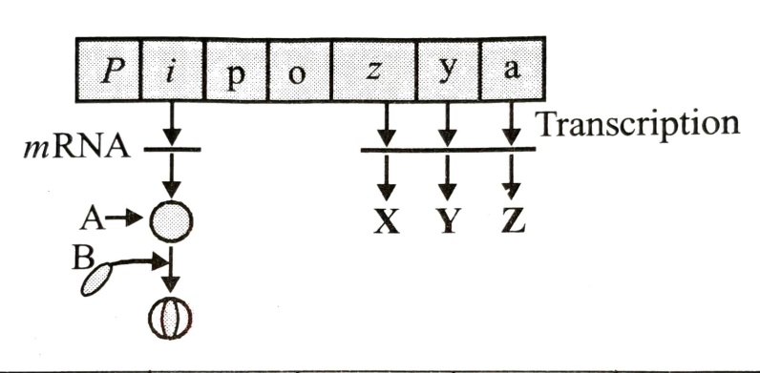

|  |  |  |  |  |  |  |
| --- | --- | --- | --- | --- | --- | --- |
|  | A | B | X | Y | Z | L |
|  | Repressor | Inducer | β – galactosidase | Permease | Transacetylase | X |
|  | Repressor | Inducer | Permease | β – galactosidase | Transacetylase | Y |
|  | Inducer | Repressor | β – galactosidase | Permease | Transacetylase | Z |
|  | Inducer | Repressor | β – galactosidase | Transacetylase | Permease | B |

1. The human chromosome with the highest and least number of genes in them are respectively

|  |  |  |  |
| --- | --- | --- | --- |
| a) Chromosome 21 & Y | b) Chromosome 1 & X | c) Chromosome 1 & Y | d) Chromosome X & Y |

1. One of the most frequently used techniques in DNA fingerprinting is:

|  |  |  |  |
| --- | --- | --- | --- |
| a) AFLP | b) VNTR | c) SSCP | d) SCAR |

1. Match the following columns

|  |  |
| --- | --- |
| **Column – I**  (Functions) | **Column – II**  (Segments of DNA) |
| 1. Segment DNA coding for polypeptide | 1. Recon |
| 1. Segment DNA goes for recombination | 1. Muton |
| 1. Segment DNA goes for mutation | 1. Cistron |

|  |  |
| --- | --- |
| a) A – 1; B – 2; C – 3 | b) A – 3; B – 2; C – 1 |
| c) A – 3; B – 1; C – 2 | d) A – 1; B – 3; C – 2 |

MOLECULAR BASIS OF INHERITANCE Page No. 31

**Answers**

|  |  |  |  |  |  |  |  |
| --- | --- | --- | --- | --- | --- | --- | --- |
| 1. b | 1. a | 1. c | 1. b | 1. c | 1. c | 1. d | 1. a |
| 1. b | 1. b | 1. d | 1. c | 1. d | 1. b | 1. d | 1. c |
| 1. a | 1. a | 1. c | 1. c | 1. b | 1. b | 1. a | 1. b |
| 1. a | 1. d | 1. d | 1. b | 1. c | 1. c | 1. b | 1. a |
| 1. a | 1. a | 1. c | 1. b | 1. b | 1. d | 1. d | 1. d |
| 1. d | 1. b | 1. a | 1. c | 1. a | 1. d | 1. d | 1. a |
| 1. a | 1. c | 1. b | 1. a |  |  |  |  |

MOLECULAR BASIS OF INHERITANCE Page No. 33